ID 212: The house should be green.
ID 213: The roof of the house should be flat.
ID 214: The windows of the house should be contain three layers of glas.

ID 216: The life time of the house should be ensured for 100 years.
ID 217: A house should be sold inclusive two car ports.
ID 218: A third car port is always an option.
ID 219: This requirement is an placeholder.
ID 220: The ebit of the house should be 17%.

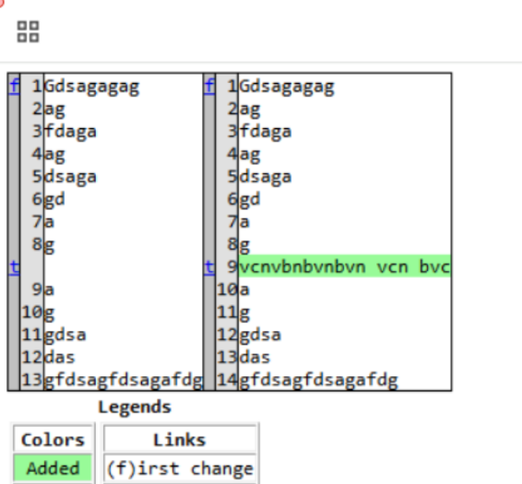
ID 221:

ID 222: After comletion of the house an warenty of 10 years is promised.
ID 225: Erliest production should be 2027.

